Founders Day Activity

Bike Hike

Sunday, February 22nd 10.00AM
Banyule District Cubs Iv
Please wear your cub uniform and correct footwear.
10am - Meeting at Warringal Park and riding to Wilson Reserve, Irvine Road.
Arrive at 11:30 for ceremonies, then lunch and finish approx 12:30pm
Helmet, sunnies & backpack with hat, sunscreen, lunch and drink bottle
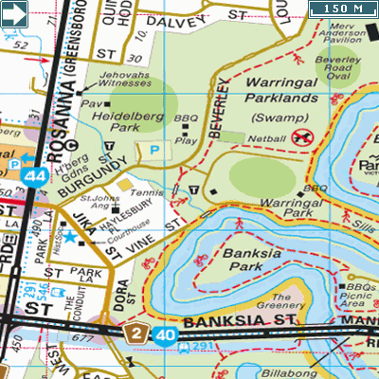
Starting point:
Warringal Park
Beverley Road off Burgundy St
Melway Ref 32-C4

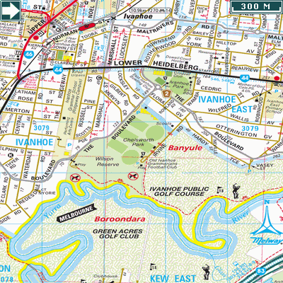

Finishing Point:
Wilson Reserve,
Ivanhoe East

Melway Ref 31-G10

BYO Picnic Lunch

Contact number for this event:
Cheryl Borg on 0417 522 302

